FORM 2 MATHEMATICS
END OF YEAR 2025 EXAM (OCTOBER) TIME: 2 HOURS
M/SCHEME

1. | Let the other number be x | M1  A1

2 -5 x 6 ÷ 2 + (-5)
. -12 -3 = 4
4 x 4 + 15
Numerator 16 + 15 = 31
Denominator -5 x 3 + -5 = 31
-15 + -5
-15 + -5
= -20
31
-20
= - 1 ¹¹_{/20}
3 |  | Difference = 216  Difference of multipliers = 100 – 1 = 99  Fraction |  | B1  M1A1  3
4. |  |  | M1  M1  A1

5.3 x 1 - 2x 1
1.36 x 10⁻² 13.84

3 x 8.575 – 2 x 0.07224
= 25.725 - 0.14448
= 25.58052
= 25.58

6. 3(x + y) – (x –y)
X ² - y²
= 3x + 3y – x + y
x² - y²
= 2(x +2y)
x² -y²
 | 7. |  |  |  |  |  | Number of hours reduces in ratio 15:16 from increase in the number of men.  No. of hrs increase in ratio 24:20 from reduction in the days |  |  |  | M1  M1  A1 |  | Both ratio
8. |  |  | LSF 1 cm rep 50000cm  1cm rep 500m  ASF 1cm2 rep 250000m2  Area =  = 154ha |  |  |  |  |  |  | B1  M1  A1 |  |  |  | ASF given
9 |  |  | 7 -3x + 2 < x + 6 x > 1 x + 6 ≤ 17 − 2x x ≤ 3⅔ 2, 3 B₁ B₁ B₁ 3
 | 10 |  |  | 1 $ Kshs. 77.43  5600$ = (5600 x 77.43)  = 433608  Spent 201,367  Remainder = (433608 – 201367)  = 232241  1SR shs.9.51  Shs.232241  1 x 232241  9.51  - = shs.24420.715
 | 11
 | 12 |  |  | 2x + 40 + x – 25  3x + 15 + 9 = 180  3x + 15 = 29  9 = ½ (3x + 15)  3x + 3x = 180 -15-15  2 2  x = 35º  x = 35 = 10º  ½ ( 10 + 110) = 60º
 | 13 |  |  | 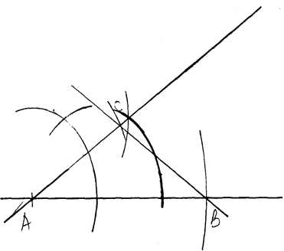  BC = 3.5 cm + 0.1 B₁  B1 construction of ∠CAB.  B1 completion of triangle.
 | 14 |  |  | L/S.F = ^{2.2}/_{3.3} = ²/₃  ^{4.8}/_{4.8 + h} = ²/₃  h= 24  volume of smaller cone  ¹/₃ x ²²/₇ x 2.2 x 2.4  = 12.169  Volume of large cone  ¹/₃ x ²²/₇ x 3.3 x 3.3 (4.8 + 2.2)  ∴ V of frustum  82.14 – 12.17 = 69.97 cm³
 | 15 |  |  | Area scale factor = 12: 108  = 1: 9  Linear scale factor = √1 : √9  = 1 : 3  Volume scale factor = 1³ : 3³  = 1 : 27  Volume of the smaller cone = 810cm³ x 1  27  = 30cm²
 | 16 |  |  | Tan 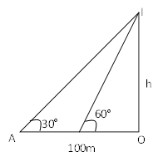30º = x x  100+ y  x = (100 + y) tan 30º  (100 + y) tan 30^{o =} y tan 60º  Tan 60º = x = x = y tan 60º  ^{y}  (100 + y) 0.5774 = 1.1732y  57.74 = 1.155y  y = 57.74  1.155  y = 49.99 ≡ 50m  ∴x = 50 tan 60  x = 86.6m
 | 17. |  |  | - (i)  h = 90  Π × 1600 × 120 − ⅓ Π× 900 × 90  (64 000 Π − 27 000) ÷ 1000  37 Π litres  (ii) Volume of water =  =777.6 Π litres  = 22 |  |  |  |  |  |  |  | M₁  A₁  M₁  M₁  A₁  M₁  A₁  M₁  M₁  A₁ |  |  | Divide by 1000  Mult by 1000
 | 18. |  |  |  |  | (a) (i) 800 x 0.2  = 160m³  (ii) 160 x 2000  = 320,000kg  (iii) Cement = ²/₈ x 320,000  = 80,000  (b) Bags = 80,000  50  = 1600  (c) Ballast = ³/₈ x 320,000  = 120,000 tonnes  = 120 lorries |  |  |  |  |  | M1  A1  M1  A1  M1  A1  B1  B1  M1  A1  B1
 |  | 20. |  |  | (a)  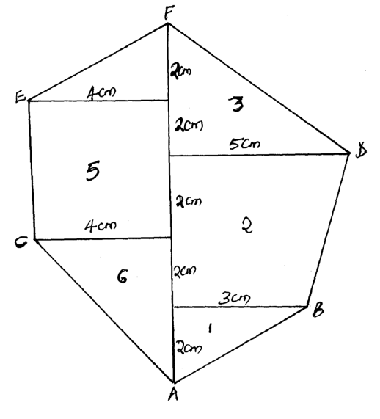  (b) Area1 = ½ x 2 x 3 = 3cm2  Area2 = ½ x 4(5+3) = 16cm2  Area3 = ½ x 5 x 4 = 10cm2  Area4 = ½ x2x4 = 4cm2  Area5 = 4 x 4 = 16cm2  Area6 = ½ x 4 x 4 = 8cm2  Total area = (3+16+10+4+16+8)cm2  = 57cm2  Actual area = (57x100)m2  = 5700m2  (c) 10,000m2 = 1ha  5700m2 = ?  1 x 5700  10,000  = 0.57ha |  |  | S1  B1  B2  B1  B1  M1  A1  M1  A1 | Scale  Base line  Offsets (all – offsets) A want B1 for at least 2  (3 areas)  (3 areas)  Addition of all six areas
 |  | 21 |  |  | Distance covered by Kinyua in 1²/₃hrs  = 5 x 90 = 150km  Distance traveled by Nyaboke during the rest = (¹/₃ x 120) = 40km  x = 390 – x ⇒ 120x = 90(390 – x)  90 120  = 167.1km  Time = 167.1 = 1.86  90  8.33 + 1.86 = 10.19; they met at = 10.11a.m  580 – (150 + 167 .1) = 262.9km from M  Before the rally driver started, Nyaboke had traveled for 1 ½ hrs  ( ³/₂ x 120) = 180km  x = x + 180  120 80  180x – 120x = 21600  x = 360km  Distance from K = 580 – (180 + 360)  x = 40km  Time = 540 = 3hrs  180  (9.30 + 3hrs) = 12.30p.m
 |  | 22 |  |  | <QRO = 300 Base angles of isosc. Triangle  <ROT = 100-120 = 600<s on straight line  <ROT = 600  <ORP = 600 Base angles of Isoc triangle  <QRS = 900 diameter subtended right angle at the circumference  (a) <SRQ = 900 – 30 - 300  = 300  <QRO + ORP + SRP = 900  Diam. Subt 900 at circumference  (b) ORP = 600 Base angle of isosceles triangle  (c) OP to MPT <OPT = 900  Radius meets tangent at 900  <RTP = 900 - <OPR  = 900 - 300  = 600  (d) <STP = 1800 - <OPT 900 - <POT 600  Angle sum of triangle  = 300  (e) <QPM = <QRP = 600  Angles in alternate segment |  |  | B1  B1  B1 B1  B1  B1  B1  B1  B1  B1
 |  | 23
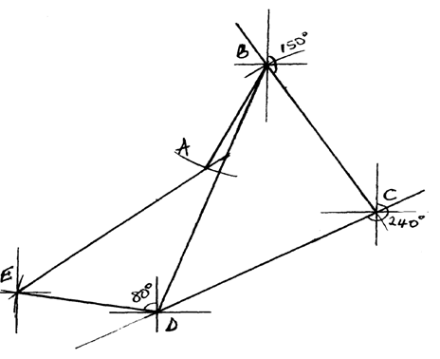
b) i) 6.8 + 0.1cm
Distance Ae = 340 + 5 km
24.
ii) 180 + 18 = 198 + 2

